Project 3
Botnet PCAP Trace Analysis Using Wireshark
Objective
- To use Wireshark to analyze network packets of a botnet.
Description
- Students may work individually or form a team of up to four members to complete the project. While teamwork is allowed, students are encouraged to complete the project on their own.
- All students must submit their own answers to this project.
- Graduate students are required to answer all questions.
- Undergraduate students may select questions totaling 24 points to answer. The maximum score for an undergraduate student will be capped at 24, regardless of how many questions are attempted.
Submission
- All students must complete Project 3, which is listed under the Quiz category;
- All students must also submit an analysis report (using this template) explaining how the results were derived from the given trace. Students working in the same team may submit an identical report; however, each student must upload the report individually.
- For your answer to each question in the analysis report, please include the screenshot of the relevant code snippet and your analysis.
Pcap File and Additional Information
- You can download the pcap file of the network traffic from this link.
- You will find the source code of the bot in HW3 helpful.
- You will find the IRC protocol useful for this project.
The Tool
- You are recommended to use Wireshark to complete this project.
- You may want to use the Wireshark's "filter" functions to expediate your analysis.

Your Name: Josiah Schmitz
UID: U01049737

Q1. Which of the following IP addresses is the botnet’s command-and-control (C2) server?

192.168.1.128
192.168.1.129
192.168.1.132
192.168.1.134

Screenshot
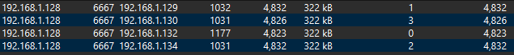
Answer: By looking at the TCP conversations between IP addresses, we see that 192.168.1.128 is only communicating with these 4 IP addresses (.129, .130, .132, .134) and is sending a large number of packets between them on port 6667. This indicates that 192.168.1.128 is almost certainly the C2 server.

Q2. Identify the port number used by the botnet’s command-and-control (C2) server to control bots.
6667, 80, 443, 53
Screenshot

Answer: Using the same screenshot as for Q1, we see that the communication between 192.168.1.128 and the other IP addresses occurs entirely on port 6667.

Q3. What application-layer protocol is used by the botnet’s command-and-control (C2) channel?
IRC, HTTP, HTTPS, FTP
Screenshot
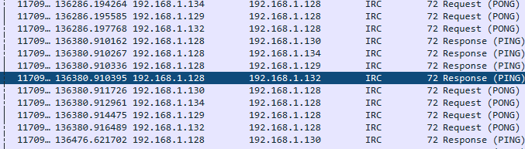
Answer: In the above screenshot, we can see that many of the packets sent between 192.168.1.128 and the other IP addresses are sent via IRC protocol. This would seem to indicate that IRC is the main protocol used for the C2 channel. I also verified this by looking at the statistics of how many IRC packets are sent in this pcap file.

Q4. Identify bots' IP addresses.
192.168.1.128
192.168.1.129
192.168.1.130
192.168.1.132
192.168.1.134

Screenshot

Answer: Using this screenshot of the communication between the C2 server and other IP addresses again, we get a very clear list of the addresses the C2 server connects to. These four addresses are 192.168.1.129, .130, .132, and .134. This means that these addresses are almost certainly all bots.

Q5. What is the most likely password used by the botmaster to log in to the bots?
12345, password, ATtaCK!, test
Screenshot
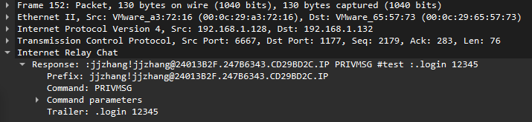
Answer: The above screenshot shows the contents of a TCP packet where a login command is sent. In the response line, we can see a login attempt is made with the string “12345”. This means that “12345” is most likely the password.

Q6. What is the most likely version of the operating system on the compromised bots?
Windows XP (5.1, Build 2600)
Windows 2000 (5.1, Build 2600)
Windows NT (5.1, Build 2600)
None of above
Screenshot
Answer: By searching TCP packets for keyword “Windows,” I found several packets (like the one shown above) that make a “sysinfo” call to the system. The output of this command then returns the OS version of the system being attacked, which is shown above to be Windows XP (5.1, Build 2600).

Q7. Which of the following commands is used by the botmaster to scan the network of compromised hosts (bots)?
.advscan, .sysinfo, .login, .flusharp
Screenshot
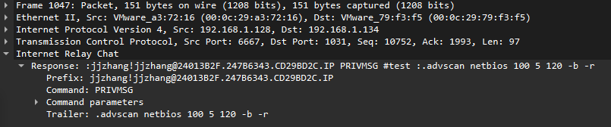
Answer: I filtered TCP packets by ones that contain “.advscan” and found several (one for each bot) response packets from the C2 server using this command as seen above. Given that this is the only one of the four commands listed above that actually does network scanning, it would make sense that “.advscan” is what is being used to scan the bots’ network.

Q8. All compromised hosts (bots) use the same Microsoft Windows Product ID CD Key.
True/False
Screenshot
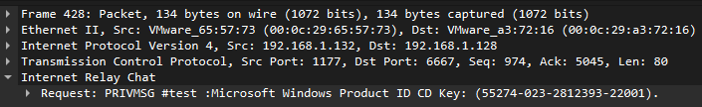
Answer: By filtering TCP packets by those that contain “Windows”, I found that there is a response and request packet, similar to the one above, for each bot. Each packet contains the Product ID Key and comparing them shows that each bot has the exact same key (55274-023-2812393-22001).

Q9. The botmaster issued the command dns www.sina.com.cn instructing each bot to perform a DNS query for that domain. Which bots followed this instruction and actually sent the DNS query?
192.168.1.129
192.168.1.130
192.168.1.132
192.168.1.134

Screenshot
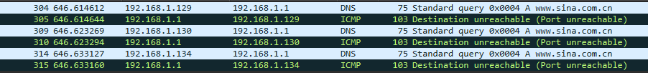
Answer: By finding all DNS packets that query www.sina.com.cn, I found the 6 packets shown in the screenshot above. We can see in this image that all of the bots except for 192.168.1.132 sent out the query (even though the port was unreachable).

Q10. Which of the following commands were issued by the attacker to the bots?
.flusharp
.getcdkeys
.procs
.getclip
.netinfo
Screenshot
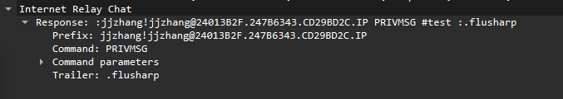
Answer: By filtering several times to find TCP packets that contain the commands above, I found packets (such as the one pictured above) that show that each of the five commands was sent from the attacker to the bots via IRC.
Q11. The botmaster issued the command .advscan netbios 100 5 120 -b -r, instructing each bot to perform TCP SYN scanning of port 139 (NetBIOS) against hosts in the same subnet. Bots should send a large number of TCP SYN packets to that subnet, causing a large number of failed TCP connections. Sometimes, bots do not follow the command. Please identify bots that did not execute this command.
192.168.1.129
192.168.1.130
192.168.1.132
192.168.1.134
Screenshot
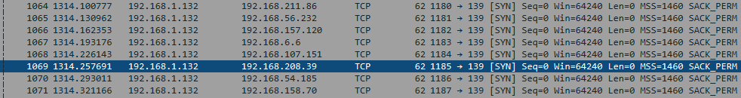
Answer: Shortly after the C2 server sends the commands to each bot (frames 1045-1048), chunks of packets like the ones shown above start showing up. These look to be failed TCP SYN connections, just like the instructions above indicated. Continuing to look through these kinds of packets, I found that every bot sent large chunks of similar packets to the subnet except for 192.168.1.130, indicating that this bot never followed the command.

Q12. Which of the following bots likely issued ARP scanning to discover active IP addresses in the local area network?
192.168.1.129
192.168.1.130
192.168.1.132
192.168.1.134
Screenshot
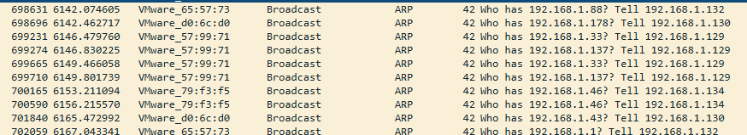
Answer: When filtering by ARP protocol, I found many request packets scanning the 192.168.1.0/24 subnet. All four of the bots’ IP addresses were listed as scanning these addresses (see screenshot). This seems to indicate that all 4 bots are performing ARP scanning.

